**Inter-conversion of state space and transfer function**

**Lab report #07**



Fall 2022

CSE-310L Control Systems

Submitted by: **Ashfaq Ahmad**

Registration No: **19PWCSE1795**

Class Section: **B**

“On my honor, as student of University of Engineering and Technology, I have neither given nor received unauthorized assistance on this academic work.”

Student Signature: ______________

Submitted to:

**Dr: Muniba Ashfaq**

**Nov** 29, 2022

**Department of Computer Systems Engineering**

**University of Engineering and Technology, Peshawar**

**Objective(s)**

* To know about TF and SS representation.
* To know about inter-conversion of TF and SS.

**tf2ss:**

* This built-in function is used to convert TF to ss.
* It takes num and denum as input and returns four matrices A B C and D of state space.

**ss2tf:**

* This built-in function is used to convert ss to TF.
* It takes four matrices A B C and D of state space as input and returns num and denum of TF.

**ss:**

* It takes four matrices A B C and D of state space as input and returns a state space model.
* Then we pass state space model from tf built-in function to give tf.

**Task01:**

Convert given transfer function to state space.

s^3 + 7 s^2 + 2 s

-----------------------

s^3 + 9 s^2 + 26 s + 24

**Source code:**

clc

clear

close all

num=[1,7,2,0];

denum=[1,9,26,24];

tf(num,denum)

[A,B,C,D]=tf2ss(num,denum)

**Output:**

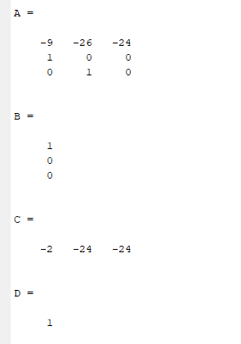

**Task02:**

Convert given state space function to transfer function.

A=[-4 -1.5; 4 0];

B=[2;0];

C=[1.5 0.625];

D=0;

**General form of ss is:**

dx/dt=Ax(t)+Bu(t)

y(t)=Cx(t)+Du(t)

**source code:**

clc

clear all

close all

A=[-4 -1.5; 4 0];

B=[2;0];

C=[1.5 0.625];

D=0;

[num,denum]=ss2tf(A,B,C,D);

tt=tf(num,denum)

**Output:**

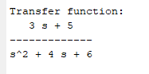

**Task03:**

Convert given transfer function to state space.

8 s + 10

----------------------------

s^4 + 5 s^3 + s^2 + 5 s + 13

**Source code:**

clc

clear

close all

num=[8,10];

denum=[1,5,1,5,13];

[A,B,C,D]=tf2ss(num,denum)

**Output:**

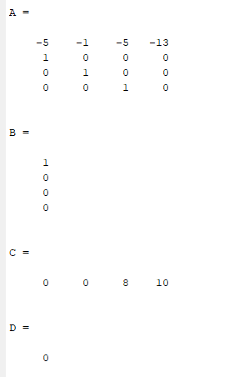

**Task04:**

Convert given transfer function to state space.

s^4 + 2 s^3 + 12 s^2 + 7 s + 6

------------------------------

s^5 + 9 s^4 + 13 s^3 + 8 s^2

**Source code:**

clc

clear

close all

num=[1,2,12,7,6];

denum=[1,9,13,8,0,0];

[A,B,C,D]=tf2ss(num,denum)

**Output:**

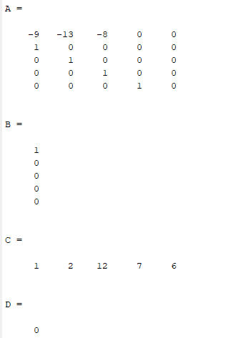

**Task05:**

Convert given state space function to transfer function.

A=[0 1 5 0;0 0 1 0;0 0 0 1; -7 -9 -2 -3];

B=[0;5;8;2];

C=[1 3 6 6];

D=0;

**Source code:**

clc

clear all

close all

A=[0 1 5 0;0 0 1 0;0 0 0 1; -7 -9 -2 -3];

B=[0;5;8;2];

C=[1 3 6 6];

D=0;

tt=ss(A,B,C,D);

tt=tf(tt)

**Output:**

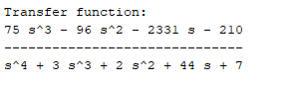

**Task06:**

Convert given state space function to transfer function.

A=[3 1 0 4 -2;-3 5 -5 2 -1;0 1 -1 2 8;-7 6 -3 -4 0; -6 0 4 -3 1];

B=[2;7;8;5;4];

C=[1 -2 -9 7 6];

D=0;

**Source code**:

clc

clear all

close all

A=[3 1 0 4 -2;-3 5 -5 2 -1;0 1 -1 2 8;-7 6 -3 -4 0; -6 0 4 -3 1];

B=[2;7;8;5;4];

C=[1 -2 -9 7 6];

D=0;

tt=ss(A,B,C,D);

tt=tf(tt)

**Output:**

